Watershed and oceanic controls on spatial and temporal patterns of sediment accumulation in a fringing coral reef embayment: Faga'alu Bay, American Samoa

by

Messina, A.M.1*, Biggs, T.W.1, Storlazzi, C.D.2

1 San Diego State University, Department of Geography, San Diego, CA 92182, amessina@rohan.sdsu.edu, +1-619-594-5437, tbiggs@mail.sdsu.edu, +1-619-594-0902

2 US Geological Survey, Pacific Coastal and Marine Science Center, Santa Cruz, CA 95060, cstorlazzi@usgs.gov, +1-831-460-7521, ocheriton@usgs.gov, +1-831-460-7579

# Abstract

Anthropogenic watershed disturbance has increased sediment stress on many coral reefs, and integrated ridge-to-reef understanding of sediment dynamics is needed to support coral conservation. Sediment accumulation on flat-surfaced sediment pods and in tubular sediment traps was monitored quasi-monthly for one year at 9 sites in Faga’alu Bay, American Samoa, and related to suspended sediment yield from the adjacent watershed, wave heights, benthic sediment composition, and water circulation patterns in the small, coral reef-fringed embayment. Similar to other studies, sediment pods measured an order of magnitude less sediment accumulation than adjacent sediment traps. Sediment accumulated in traps was predominantly carbonate and generally reflected the composition of surrounding benthic sediment at each site, though sites on the north reef showed higher terrigenous fractions than the surrounding seabed, suggesting enrichment by terrigenous stream discharge. Terrigenous sediment accumulation in the sediment trap nearest the stream outlet was significantly correlated with suspended sediment yield from the stream, but not at sites on the reef flat, suggesting accumulation was dominated by fluvial processes only near the stream outlet. Sediment accumulation rates in some sediment traps on the reef flat and fore reef were significantly correlated with mean wave heights, suggesting wave-driven resuspension of reef-derived sediment was the dominant source of sediment accumulation in those areas. Sediment accumulation on sediment pods, however, was negatively correlated with wave heights on the reef flat and forereef, suggesting any accumulated sediment from resuspension was removed by advection and residence time was low. Average sediment accumulation on sediment pods and in sediment traps exceeded literature values for coral health impact thresholds in some collections, near the stream outlet, over the more quiescent northern reef, and in deep areas on the fore reef near the channel incised into the reef flat. The understanding of sediment accumulation patterns and their potential impact on coral health developed here was accomplished using relatively simple methods that require few technical and personnel resources, and strongly supports local management actions to reduce sediment yield from the watershed.

Keywords:

coral reefs, sediment accumulation, sediment pods, sediment traps, American Samoa

# 1. Introduction

Coral reefs adjacent steep, mountainous watersheds are exposed to both reef-derived carbonate sediment and watershed-derived terrigenous sediment which is increasing from anthropogenic disturbance on many tropical islands (Bégin et al., 2014; Hettler et al., 1997; Messina & Biggs, 2016; Ramos-Scharrón & Macdonald, 2007). Increased suspended-sediment concentrations (SSC) can reduce coral health by attenuating photosynthetically active radiation (PAR) (Curt D. Storlazzi et al., 2015) and interfering with coral spawning (Erftemeijer et al., 2012). Increased sediment deposition and accumulation can further impact corals by blocking all light for photosynthesis, causing tissue damage (Weber et al., 2012), requiring energy for self-cleaning, and blocking larval recruitment sites (DeMartini et al., 2013; Jokiel et al., 2014). Increased sedimentation also decreases numbers of fish (DeMartini et al., 2013) and thus herbivory of algal turf (Bellwood & Fulton, 2008); increased algal height can further increase sediment trapping. Reduced herbivory of turf algae stabilizes a phase shift to an algae-dominated system and reduces fish biomass, for many fish prefer to graze on algae free of sediment (Tebbett et al., 2017).

Many researchers and environmental managers are interested in determining the location and severity of terrigenous sediment impacts on coral health, but developing a measure of sediment impact has proven difficult. Some have measured SSC in the water column to determine sediment stress (Fabricius et al., 2012; Wolanski et al., 2003), but they do not show if sediment is accumulating on the coral, the residence time, or the composition of the sediment, which are important for overall impact (Erftemeijer et al., 2012; Weber et al., 2012). Thus, direct measurements of net sediment accumulation and composition are preferred (Field et al., 2012).

Tubular sediment traps are the most common method for directly measuring sediment accumulation in shallow coral reef environments (Curt D. Storlazzi et al., 2011), but it is difficult to determine if these are ecologically meaningful indicators of coral stress. Sediment traps overestimate deposition and do not allow for sediment resuspension, making it impossible to evaluate the residence time of deposited sediment (Browne et al., 2012; Curt D. Storlazzi et al., 2011). To more accurately quantify “net” sediment accumulation, Field et al. (2012) proposed the use of sediment pods, or “SedPods,” where a flat surface allows for resuspension, similar to the surrounding benthic substrate, but few examples of this approach exist in the literature. Deploying a sediment trap in conjunction with a sediment pod allows comparison of gross and net sediment accumulation and can assess the interaction of terrigenous sediment inputs and transport at time scales relevant to coral mortality and management.

The complex interactions of terrigenous sediment inputs and hydrodynamic processes can significantly alter the quantity, composition, and residence time of sediment in coral reefs (Draut et al., 2009; Curt D. Storlazzi et al., 2009) and impacts on coral health depending on species and morphology (Duckworth et al., 2017). Some studies correlate increased suspended-sediment yield (*SSY*) from the watershed with long term sediment accumulation and, by extension, decreased coral health (Brooks et al., 2007; DeMartini et al., 2013; Ryan et al., 2008). Rainfall is often used as a proxy for storm-supplied terrigenous sediment because it is most readily available (Meng et al., 2008), but several studies have found weak or no correlation between sediment trap accumulation and rainfall (Bothner et al., 2006; Victor et al., 2006). *SSY* from small, mountainous watersheds can be poorly correlated with precipitation (Basher et al., 2011; Duvert et al., 2012), and hydrodynamic resuspension of previously deposited terrigenous sediment can increase accumulation rates (DeMartini et al., 2013). Where management activities reduce sediment yields from storm events, it is necessary to measure *SSY* from the watershed.

Sediment stress on corals increases linearly with the severity and duration of exposure (Fabricius, 2005), but hydrodynamics decrease sediment residence time in two ways: 1) flushing and preventing deposition of suspended sediment, and 2) resuspending and removing deposited sediment (Browne et al., 2012; Hoitink & Hoekstra, 2003). In contrast to many temperate coastal regions where fluvial discharge and wave energy commonly coincide during “oceanic storms” (Bever et al., 2011; Warrick et al., 2004), input, deposition, and reworking of terrigenous sediment are often decoupled on tropical islands, causing high deposition rates and residence times (Draut et al., 2009; Curt D. Storlazzi et al., 2009). Conversely, seasonal wind and wave patterns in the trade-wind belt can be coupled with terrigenous sediment input from the watershed or resuspension of past deposits to decrease sediment deposition and residence times (Hoitink & Hoekstra, 2003; Muzuka et al., 2010; Curt D. Storlazzi & Jaffe, 2008). Determining the fate of terrigenous sediment delivered to the coast during storms requires contextualizing observed watershed-derived sediment yields with hydrodynamic conditions like wave-driven currents over the reef

Determining the effectiveness of land-based watershed restoration requires a spatial understanding of terrigenous sediment input and hydrodynamics which control sediment transport, deposition, resuspension, and advection out of coral reefs (Curt D. Storlazzi et al., 2015). Many conservation planning studies use coarse estimates of pollutant discharge coupled with distance-based plume models that assume symmetry in flow fields (Klein et al., 2012; Teneva et al., 2016). Many studies that deploy sediment traps typically deploy them near the stream outlet or haphazardly over the reef, but sediment accumulation can vary with depth (Wolanski et al., 2005), distance from the sediment source (DeMartini et al., 2013), or due to water circulation patterns (Bothner et al., 2006; Hoitink & Hoekstra, 2003), so it is uncertain how those observations relate to the two-dimensional spatial patterns of sediment accumulation over the reef.

Here we interpret spatial and temporal sediment accumulation patterns in a coral reef-lined embayment using measured and modeled event suspended sediment yield (*SSYEV*) from the watershed, modeled wave conditions, and the resulting circulation patterns, and spatially-distributed measurements of gross and net sediment accumulation and composition. The goal of this effort is to understand the influence of source proximity, circulation patterns, and water depth on terrestrial and carbonate sediment accumulation in a reef-lined embayment impacted by excessive terrestrial sediment loading, and its resulting impact on coral health.

# 2. Materials and Methods

## 2.1 Study Area

### 2.1.1 Geography and Geology

Faga'alu Bay is a v-shaped, fringing-reef embayment situated on the western side of Pago Pago Bay, on the island of Tutuila, American Samoa (14.290˚ S, 170.677˚ W; Figure 1). Faga'alu Bay is adjacent to a small (2.48 km2) watershed that is covered primarily with undisturbed vegetation on the steep hillslopes (82%), with a small urbanized village area on the flatter lowlands (7%) and an aggregate quarry (1%). Total relief of the watershed is 653 m, and mean slope is 0.53 m/m. The perennial Faga’alu Stream drains 1.78 km2 of the watershed into the northwest corner of the bay, and the remaining 0.78 km2 drains directly to the bay in several surrounding ephemeral streams (Messina and Biggs, 2016). Soil types in the steep uplands are rock outcrops (15% of the watershed area) and well-drained Lithic Hapludolls ranging from silty clay to clay loams (Nakamura, 1984), whereas soils in the lowlands are a mix of well drained very stony silty clay loams and poorly drained silty clay to fine sandy loam along valley bottoms.

The complex bathymetry of Faga’alu Reef is characterized by a shallow reef flat extending from shore to the reef crest, where it descends at an approximately 1:1 slope to the insular shelf at approximately 20 m depth. See Cochran et al. (2016) for a detailed description of the bathymetry and benthic cover. An anthropogenically-altered, vertical-walled, 5-15 m deep paleostream channel (“channel”) (Figure 1c) extends from the outlet of Faga'alu Stream in the northwest corner, eastward to Pago Pago Bay. This channel divides the reef into a larger, southern section exposed to ocean swell (“southern reef” in Figure 1), and a smaller, more sheltered northern section (“northern reef” in Figure 1). Closer to the shore in the southern back-reef there are areas of deeper (1-5 m) sediment-floored pools with coral bommies (“back-reef pools” in Figure 1).

Near the reef crest, the reef flat is primarily cemented reef pavement, but within a few 10s of m, transitions into thickets of primarily *Acropora spp.* Surveys in 2015 found coral coverage varied from less than 10% over the degraded northern area, to more than 50% on the more intact southern area (Cochran et al., 2016; Holst-Rice et al., 2016). Sediment availability is relatively low on the reef flats near the reef crest, though there are some patches of accumulated carbonate sediment. Near the stream outlet, the benthic surface is primarily sand and fine silt.

### 2.1.2 Meteorology, stream flow, and oceanography

Annual precipitation (*P*) in Faga'alu watershed varies with elevation from 6,350 mm at Matafao Mtn. (653 m elevation) to 3,800 mm on the coastal plain (Craig, 2009; Dames & Moore, 1981; Perreault, 2010; Tonkin & Taylor International Ltd., 1989; Wong, 1996). There are two rainfall seasons: a drier winter from June through September accounts for 25% of annual *P*, and a wetter summer from October through May accounts for 75% of annual P (Craig, 2009; Perreault, 2010). *P* is lower in the drier season but large storms still occur: at 11 stream gages around the island, 35% of annual peak flows occurred during the drier season (1959-1990) (Wong, 1996).

Storms occur most frequently during the October-April wet season, but large storms can occur throughout the year (Messina & Biggs, 2016; Wong, 1996). Storms generate an estimated 241-368 tons/km2/yr of suspended sediment yield (*SSY*) to the bay from undisturbed, forested areas in the uplands (13% of total *SSY*), and anthropogenically disturbed open-pit aggregate quarry and village areas in the lowlands (87% of total *SSY*). The significant sediment contribution from the quarry prompted mitigation efforts including revegetation, covering road surfaces, and groundwater diversion in 2013, and retention ponds in October 2014, which significantly reduced sediment runoff into Faga'alu Stream and *SSY* into the Bay. See Holst-Rice et al. (2016) for a full description of sediment mitigation at the quarry.

Faga'alu Bay is surrounded by high topography that blocks wet-season northerly winds, but is exposed to dry-season southeasterly trade winds and accompanying short-period waves. Trade winds are typically most prevalent and strongest during the dry season, but are common throughout the year (Craig, 2009). Tropical cyclones typically occur in the South Pacific from November to April (Militello et al., 2003), making landfall over American Samoa every 1-13 years since 1981 (Craig 2009), though cyclogenic waves impact the reefs more frequently (Feagaimaalii-Luamanu, 2016). Faga'alu Bay is only open to south to southeast swell directions, and the more southerly angled swell must refract to the west, resulting in a reduction of wave energy. Offshore significant wave heights are generally less than 2.5 m and rarely exceed 3.0 m. Peak wave periods are generally about 9 s or less, rarely exceed 13 s, but occasionally reach 25 s during austral winter storms (Thompson & Demirbilek, 2002). O. Vetter (unpublished data) recorded significant wave heights up to 1.7 m on the fore reef in Faga'alu, but significant wave heights greater than 1.0 m were infrequent. A semi-diurnal, microtidal regime exposes parts of the shallow reef crest and reef flat at extreme low tides, and water circulation increases with tidal height (C. D. Storlazzi et al., 2018).

GPS-logging drifter and acoustic current meter deployments in 2014 showed mean flow speeds (residence times) over the reef flat varied widely, from 1-20 cm s-1 (2.8-0.14 h), 1-19 cm s-1 (2.8-0.15 h), and 1-36 cm s-1 (2.8-0.08 h) under strong wind, tidal, and large wave forcing, respectively (C. D. Storlazzi et al., 2018). The highest flow speeds and shortest residence times occurred over the exposed southern reef and near the reef crest. The slowest flow speeds and longest residence times occurred over the sheltered northern reef, near shore, and over the deep channel incised in the reef. Under tidal forcing (i.e., calm conditions), flow directions were the most variable, with some seaward transport from the southern reef flat to the fore reef. Under onshore trade wind forcing, flow directions were mostly into the embayment. Under large wave forcing, flows followed a clockwise spatial pattern: onshore over the exposed southern reef, onto the sheltered northern reef, and out to sea through the channel and over the forereef.

## 2.2 Methods

### 2.2.1 Terrigenous suspended-sediment yield (*SSY*)

A time-series of *SSYEV* to the Bay during the study period was developed from measured *SSYEV* when both water discharge (*Q*) and suspended sediment concentration (*SSC*) data were available; when only *Q* data were available, *SSYEV* was predicted from the empirical *Qmax-SSYEV* models of Messina and Biggs (2016). A second *Qmax-SSYEV* model was calibrated for the time period following the sediment mitigation (October 2014-April 2015) to reflect the reduction in *SSYEV* from the same magnitude *Qmax* (unpublished). Additional terrigenous sediment yield to the bay from ephemeral streams was not measured, but assumed to be correlated with *SSYEV* from Faga’alu Stream.

### 2.2.2 Marine sediment collection and composition

Two types of sediment accumulation sampling devices were used: 1) flat-surfaced sediment pods (SedPods) (Field et al., 2012) and 2) tubular sediment traps (Traps) (Curt D. Storlazzi et al., 2009, 2011). SedPods and traps were located to sample sediment accumulation across gradients in distance from the stream outlet, hydrodynamic forcing, and depth. At each of 9 sites in Faga'alu Bay a SedPod was attached to the top, and a sediment trap was attached to the side of the same cement block (Figure 2). Six sites were on the reef flat (water depth 1-2 m) and three sites were on the fore reef (10-15 m) (Figure 1, Table 1). Where possible, benthic sediment samples were collected to characterize surface sediment near the sediment traps and across the reef flat. Surface sediment (top 2 cm) was scooped with 50 mL HDPE centrifuge tubes and analyzed for grain size and composition.

SedPods and traps were deployed over a 12-month period from March 2014 to April 2015. A monthly time interval for collecting sediment accumulation was chosen (Muzuka et al., 2010; Victor et al., 2006) to collect enough sediment for laboratory analysis and for field logistical reasons. Actual deployment periods varied due to operational safety concerns during collections on the fore reef; deployments varied from 24 d to 53 d, with a mean deployment of 36 d (Figure 3c, dotted lines).

Sediment traps were made from 5 cm internal diameter PVC pipe, approximately 30 cm tall, with a height-to-diameter ratio of 6, per Storlazzi et al. (2011) recommendation of height-to-diameter ratio of 5-7. Traps were capped and transported to the lab for sediment analysis; an empty sediment trap was installed for the next deployment. Some studies deploy multiple sediment traps at each site to determine an average accumulation rate, and Bothner et al. (2006) found that sediment accumulation rates at co-located sediment traps differed by 11% on average. This study deployed a single sediment trap to minimize hydrodynamic interference per Storlazzi et al. (2011).

SedPods were made from 15.25 cm diameter PVC pipe, approximately 12 cm tall, and filled with cement poured on a rough piece of plywood to give it a slight texture approximating a coral surface (Field et al., 2012). To collect sediment from SedPods, a rubber cap was carefully slipped over and clamped to prevent sediment loss during transport to the lab (Figure 2c). In the lab, sediment was rinsed from the rubber cap and the SedPod. In many instances there was significant algal growth on the SedPod surface, so sediment was manually scrubbed from this algae layer and included in the analysis.

Sediment collected by both SedPods and traps was analyzed for weight and grain size by wet sieving, and composition was determined by the Loss on Ignition (LOI) method. Gravel-size shells and organisms (>2 mm) were sieved and removed from analysis, then the coarse (2 mm – 63 μm) and fine fractions (63 μm - 2 μm) were separated by wet sieving. The fine fraction was collected on pre-weighed 15-cm diameter, 2-μm nominal pore size glass fiber filters. To remove salts, the coarse fraction was rinsed in the sieve and the fine fraction was gravity filtered with distilled water. Coarse and fine fractions were dried at 100 C for 2 hr, cooled, and weighed separately to determine the bulk sediment mass. Geochemical composition of the coarse and fine fractions was analyzed by combusting 3 hr at 550 C for % organic and 950 C for 3 hr for % carbonate, respectively, by mass (Heiri et al., 2001; Santisteban et al., 2004). The proportion (%) of terrigenous sediment was then determined by subtraction from the % organic and % carbonate (DeMartini et al., 2013; Gray et al., 2012). Sediment accumulation results were normalized for device diameter and deployment time (g m-2 d-1) (Curt D. Storlazzi et al., 2009) to compare SedPods and traps over variable deployment times.

### 2.2.3 Time-lapse photography of terrigenous sediment plumes

A Moultrie GameSpy I-35 timelapse camera was installed in January and February 2014 to characterize the variability of surface properties in the bay and image sediment plumes discharged from Faga’alu Stream following storms. The camera was deployed on the south side of Faga'alu Bay (Figure 1) at 15-min photo interval. Although suspended-sediment concentrations cannot be quantified from the images, the brown-colored, terrigenous sediment was clearly visible in contrast to the normally clear ocean water, characterizing the spatial pattern and trajectory of the sediment plume.

### 2.2.4 Oceanic forcing

In situ wave data was not available at the study site during sediment trap deployments, but data from a wave gauge installed previously in Faga'alu for 2 months compared well with NOAA WaveWatch III Samoa Regional Wave Model (WW3) (PACIOOS, 2016). To characterize wave conditions during sediment trap deployments, mean wave height (*Hmean*, in m) was calculated from WW3 data on daily mean significant wave height during the trap deployments (Rangel-Buitrago et al., 2014; Seymour, 2011).

This analysis did not investigate the influence of winds directly, but wind waves generated by trade winds are included in the WW3 model output. Strong trade winds are typical in May-September when significant wave height is also high due to trade wind generated waves and Austral winter storms. The co-occurrence of light winds and large groundswell-generated waves is infrequent but most common during the wet season from October to May. This analysis assumes the dominant effects of strong, onshore trade winds from the southeast are adequately captured by the WW3 significant wave height and would be significantly correlated with calculated mean wave height. See Storlazzi et al., (2018) for a full description of meteorologic and oceanographic controls on flow speeds and directions in Faga’alu Bay.

### 2.2.5 Analytical Methods

Univariate and multi-variate linear regression models were used to determine how *SSY* (tons) and *Hmean* (m) influence temporal patterns of sediment accumulation rates in sediment traps and on sediment pods at each of the 9 sediment trap sites, as well as the mean accumulation of traps on the northern and southern reef. Sites 1A, 1B, 1C, 2A, and 2C were classified as the “northern reef” and sites 2B, 3A, 3B, and 3C as the “southern reef” (Table 1). The significance of the correlation between sediment accumulation and individual driving variables (*SSY* or *Hmean*) were tested with the Spearman correlation coefficient (*p*-value <0.10).

A linear regression between *SSY* and *Hmean* confirmed they were not significantly correlated and so could be treated as independent variables in the multiple regression. A multiple linear regression between sediment accumulation vs. *SSY* and *Hmean* quantifies how well each predictor is correlated with sediment accumulation, while controlling for the influence of the secondary predictor. The multiple linear regression model was assessed using the significance of *p*-values for each predictor.

This approach does not account for the phasing or sequencing of large wave events and SSY from storms within deployment periods. For instance, if a large wave event occurred prior to a large storm event, we would not expect the wave event to affect sediment accumulation from that storm-supplied sediment yield, but our measurement interval cannot resolve the difference in phasing or sequence. More sophisticated accumulation sensors that could resolve accumulation more frequently (Whinney et al., 2017) were not available at the time of deployment.

# 3. Results

## 3.1 Suspended sediment yield (*SSY*) and mean wave heights (*Hmean*)

Seasonal patterns of *Hmean* and *SSY* were hypothesized to vary such that large *Hmean* and low SSY coincide during the trade wind dry season (May-September), causing low terrigenous sediment accumulation. *Hmean* mostly followed the expected pattern with peak *Hmean* occurring around June-August and lowest during December-February, with the exception of larger than expected *Hmean* in April 2014 and January 2015 driven by discrete, large swell events (Figure 3c).

*SSY* did not follow the expected pattern of low *SSY* in the dry season and high *SSY* in the wet season. The highest *SSY* was observed during the July-September 2014 period because (1) the largest single storm recorded in the past four years occurred 25 July 2014, (Messina & Biggs, 2016), and (2) sediment mitigation at the quarry in October significantly reduced total SSY from the watershed that would have occurred during the 2014-2015 wet season (October-April) (Holst-Rice et al., 2016).

## 3.2 Time-lapse photography of sediment plumes

Storlazzi et al., (2018) showed that the orientation of wind and wave-forcing over the southern reef caused clockwise water circulation over the more energetic southern reef and out through the channel. The circulation pattern was hypothesized to cause non-uniform sediment plume dispersal over the reef by deflecting sediment plumes from Faga’alu Stream over the more quiescent northern reef, while the southern reef remained un-impacted (Figure 4a). The hypothesized plume deflection was observed using time-lapse camera deployment in January-February 2014 (Figure 4b). Under calm wave and wind conditions, the reef was clear of sediment (Figure 4c) and rainfall reached peak intensity 30 min later (Figure 4d). Less than 15 min after peak rainfall intensity, sediment discharged from the stream outlet into the bay (Figure 4e). The brown, terrigenous sediment plume propagated from the stream outlet to the northern reef crest in approximately 15 min (Figure 4f-g), exceeding the expected residence times of >60 min over the northern reef, expected under calm conditions from Storlazzi et al., (2018). The plume appears to have reached peak concentration only 45 min after the initiation of rainfall and only 30 min after the plume first entered the bay. During the 14 February 2014 rain event, GPS-logging drifters were deployed at the stream outlet at the onset of plume discharge, and remained near the stream outlet (unpublished) while the sediment plume flowed past and extended out over the northern fore reef.

## 3.3 Sediment accumulation and composition: Spatial patterns

Faga’alu Stream is the dominant source of fine terrigenous sediment, but sampled benthic sediment showed terrigenous sediment is distributed throughout the reef flat (Figure 5). Fine terrigenous sediment accounted for 1-10% (μ=3%) of fine benthic sediment, though including the coarse fraction increased the total percentage to 8-65%, with the highest percentages of fine and coarse terrigenous sediment near the stream outlet and on the more quiescent northern reef. Total benthic sediment (fine and coarse) on the northern and southern reef flats was primarily carbonate (82-88%), with small fractions of terrigenous, and only trace amounts of organics (Table 1). The terrigenous fraction was approximately 2x higher over the northern reef flat (~15%) compared to the more energetic southern reef flat (8%). Near the stream outlet, benthic sediment was dominated by the terrigenous fraction (65% terrigenous) but showed similar percentages of organics as the reef flats.

Mean sediment accumulation (gm-2d-1) during the study period was an order of magnitude higher in sediment traps than on SedPods at all sites (Figure 5). Sediment accumulation on SedPiods was higher in the more quiescent parts of the bay near the stream outlet (site 2A), on the quiescent northern reef (site 1A-C), and near the outlet of the channel (site 2C), whereas almost no sediment accumulation was observed on SedPods over the more energetic southern reef (sites 2B, 3A, 3B, 3C) (Figure 5b). Although total accumulation was lower on SedPods compared to traps, they observed generally the same spatial pattern as the traps. The only exceptions were on the energetic southern reef flat, where accumulation rates in traps were much higher than corresponding sediment pods (sites 3A and 3B) due to greater wave-driven flow and more available benthic sediment compared to sites in the quiescent, deeper back pools and on the forereef (site 2B, 2C, 3C).

Though total sediment accumulation was higher in sediment traps, the composition of organic, terrigenous, and carbonate sediment were mostly similar for sediment traps and SedPods. With the exception of the site at the stream outlet (2A), sediment accumulation was mainly carbonate in traps and SedPods. On the more energetic southern reef, the ratio of terrigenous to carbonate sediment accumulation in sediment traps reflected the composition of surrounding benthic sediment, except for sites 3A and 3B on the southern reef flat where some small storm drains contribute terrigenous sediment during storms. On the more quiescent northern reef, the terrigenous fraction was higher than surrounding benthic sediment in both traps and SedPods. The organic fraction was also higher than surrounding benthic sediment, but only in traps and not on SedPods.

## 3.4 Sediment accumulation and composition: Temporal patterns

Following the clear spatial differences in mean sediment accumulation (Figure 5), sites on the northern and southern reefs were grouped, and mean sediment accumulation was calculated to investigate temporal patterns. Mean total accumulation rates in traps and SedPods were higher on the more quiescent northern reef than the more energetic southern reef for all deployment periods (Figure 6). Although the mean sediment accumulation rates illustrate broad characterizations of sediment regimes over the northern and southern reefs, no strong temporal patterns in mean terrigenous sediment accumulation were evident in the time series. On the northern reef, mean sediment accumulation rates on SedPods were generally lower during the May-October trade wind season, and higher during the October-April wet season, but the patterns were not very strong (Figure 6a).

On both the northern and southern reefs the highest rates of total and carbonate sediment accumulation in sediment traps were associated with the three periods with highest *Hmean* (March 2014, June-July 2014, and December 2014). Carbonate sediment accumulation on SedPods was positively correlated with *Hmean* at only one site on the northern reef (site 1A) (Figure 8, Table 2), in an area with large supply of sand near the stream outlet (Figure 2d).

Univariate linear regressions (Table 2) showed total and carbonate sediment accumulation in sediment traps was positively correlated with *Hmean* at every site except near the stream outlet (site 2A), on the more energetic southern reef in coral rubble (site 2B), and on the southern fore reef (site 3C). *Hmean* was positively correlated with mean total and carbonate sediment accumulation in traps on the northern and southern reefs (Table 2), but when controlling for *SSY* in the multiple regression, only mean carbonate accumulation was weakly correlated with *Hmean* on the northern reef (Table 3).

Total sediment accumulation was negatively correlated with *Hmean* in more energetic areas near the reef crest on the northern reef (site 1B) and southern reef (site 3B) (Table 2) where benthic sediment availability was low. On the northern and southern fore reef (sites 1C, 2C, and 3C), univariate and multivariate linear regressions showed both total and carbonate sediment accumulation in sediment traps were significantly correlated with *Hmean*, and showed a nonlinear relationship with wave heights in many cases (Figure 10).

Mean terrigenous sediment accumulation in sediment traps on either the southern or northern reef did not seem to follow any pattern in *SSY* or *Hmean*, and seemed to occur at a fairly constant rate over the study period. There is some evidence that terrigenous sediment accumulation was higher on SedPods following high *SSY* in the July-August 2014 period, but terrigenous sediment accumulation on SedPods was not linearly correlated with *SSY* for any sites (Figure 8, Tables 2-3). Terrigenous sediment accumulation was only significantly correlated with *SSY* on the far southern fore reef (site 3C), and the correlation was negative. Sediment accumulation was very low at this fore reef site, and when controlling for *Hmean* in the multivariate regression (Table 3), there was no correlation (Table 3).

The strongest correlation between *SSY* and sediment accumulation (both total and terrigenous) was near the stream mouth (site 2A) (Figure 9). Total and carbonate sediment accumulation near the stream mouth were positively correlated with *SSY*, but terrigenous accumulation was not correlated with *SSY* in the univariate regression. When controlling for *Hmean* in the multivariate regression, however, terrigenous accumulation near the stream mouth (site 2A) was highly correlated with *SSY* (Table 3).

# 4. Discussion

*Hmean* was a dominant control on sediment accumulation over the reef by driving resuspension of primarily carbonate sediment surrounding sediment traps. Terrigenous sediment accumulation was only correlated with *SSY* near the stream outlet, but elevated terrigenous fractions of accumulated sediment in traps compared to benthic sediment, as well as time lapse photography of sediment plumes, showed the northern reef flat and fore reef near the channel were impacted by terrigenous sediment. Poor correlations between terrigenous sediment accumulation and *SSY* could be the result of high uncertainty (50-100%) in the measured and modeled SSYEV from Faga’alu Stream (Messina & Biggs, 2016), complex hydrodynamics at sites, daily sequencing of wave and storm events, and confounding processes like resuspension of previously-deposited terrigenous sediment near the trap.

## 4.1 Watershed and oceanic controls on sediment accumulation

Sediment accumulation was an order of magnitude higher in traps than on SedPods, indicating the enhanced trapping efficiency and reduced resuspension in sediment traps compared to SedPods. The results presented here showed the advantage of deploying co-located sediment traps and SedPods to compare gross and net sediment accumulation across spatial gradients in hydrodynamic energy as well as the temporal patterns due to interaction between terrigenous sediment inputs and wave-induced resuspension. For example, near the northern reef crest (site 1B) sediment accumulation on the SedPod was the lowest on the quiescent northern reef, at the same site sediment accumulation in the sediment trap was the highest of the northern reef sites. Total and terrigenous ediment accumulation on the SedPod at this site was negatively correlated with waves (*Hmean*), while total and carbonate accumulation in the sediment trap was positively correlated with waves (*Hmean*). This indicates resuspended sediment was deposited in the sediment trap where it was not removed, while sediment deposited on the SedPod was frequently removed by energetic wave conditions near the reef crest, compared to in the more sheltered part of the embayment.

On both the quiescent northern reef flat (sites 1A and 1B) and energetic southern reef flat (sites 3A and 3B), univariate linear regressions showed both total and carbonate sediment accumulation in sediment traps were significantly correlated with *Hmean* (Table 2), but SedPods showed no correlation. Sediment accumulation at these reef flat sites appeared to have been controlled by wave-driven resuspension of surrounding carbonate sediment that was deposited in the sediment trap, but did not remain on the SedPod due to energetic hydrodynamic conditions. Sediment accumulation on sediment traps and SedPods was expected to be lower during periods with higher mean wave heights due to flushing and removal, but sediment traps actually showed higher accumulation with higher waves. These unexpected results showed the influence of resuspension of surrounding benthic sediment that was retained in sediment traps, but not on SedPods.

*Hmean* was not significantly correlated with accumulation in sediment traps at only three sites (2A, 2B, and 3C), indicating the lack of wave-driven resuspension or a lack of benthic sediment availability. Site 2A was in the most quiescent part of the bay and site 2B was in deeper water than the other reef flat sites, which limits resuspension. Site 2B also lies on coral rubble with very little sediment near the sediment trap, and results suggest that if any carbonate sediment is transported across the shallow reef flat, (e.g., sites 3A and 3B), it is deposited as the flow enters the deeper, back reef pools and currents slow (Storlazzi et al., 2018). Forereef site 3C was the farthest from the stream outlet, which limited terrigenous sediment exposure, up-current of the reef flat, which limits carbonate sediment availability, and most exposed to wave energy, so unsurprisingly, collected sediment was nearly zero for most periods at that site.

Sediment accumulation on SedPods was expected to be higher during low *Hmean* due to lower removal rates. Indeed, the negative correlations between total sediment accumulation and *Hmean* at energetic reef crest sites on the northern (site 1B) and southern reefs (site 3B) indicates sediment was removed or deposition was prevented by active hydrodynamic conditions. Though negative correlations between accumulation on SedPods and *Hmean* were not significant at all sites, the highest sediment accumulation on SedPods coincided with average *SSY* but low *Hmean* in November 2014, suggesting low removal rates during this quiescent period.

Higher terrigenous accumulation on the northern reef was caused by relatively quiescent hydrodynamic conditions compared to the southern reef, and the configuration of sediment input from the stream and water circulation patterns that directed sediment plumes over the northern reef and channel (Storlazzi et al., 2018). Terrigenous sediment accumulation was expected to be higher during periods of low *Hmean* and higher SSY during the wet season (October-April) due to high sediment input and low removal (Figure 3a); *SSY*, however, was highest in July during the dry, trade wind season. Sediment accumulation was significantly correlated with *SSY* only near the stream outlet (site 2A), but sediment traps and SedPods showed both higher percent contribution and accumulation of terrigenous sediment on the northern reef flat (sites 1A, 1B) and fore reef near the channel (sites 1C, 2C), compared to the southern reef. Benthic sediment on the north reef, especially near the stream outlet, contained a higher percentage of terrigenous sediment (Figure 5), so these results could indicate resuspension and deposition of surrounding benthic sediment. However, all sediment traps on the northern reef showed higher terrigenous fractions than the surrounding benthic sediment, indicating terrigenous sediment supplied by the stream was advected through, but not accumulating on, the reef. This suggests that more complex hydrodynamic forcing and resuspension of previously deposited sediment are controlling sediment accumulation, and not simply a result of *SSY* at the event scale.

On the more energetic southern reef, sediment accumulation in March 2014 was anomalously high due to high carbonate sediment accumulation in sediment traps at 3A and 3B during that period. Wave-induced resuspension of nearby benthic sediment was the likely cause but similarly high *Hmean* during other periods did not cause the same magnitude of sediment accumulation. The discrepancy could be due to the calculation of *Hmean*, which would be the same for a period of low mean wave energy with a few medium wave events that caused little resuspension, versus a period of low mean wave energy punctuated by one exceptionally high wave event that caused exponentially more resuspension, which appears to be the case in March 2014 (Figure 3b). There is also the possibility that carbonate sediment builds up over periods of low waves and trade winds during the wet season, which is then resuspended and advected through the reef during the onset of large wave events and depleted until the following wet season. A similar temporal pattern of terrigenous sediment movement may be occurring over the northern reef. Mean terrigenous sediment accumulation on pods over the northern reef appeared to be higher following the July 2014 period when an exceptionally large storm delivered a large amount of terrigenous sediment (Figure 6a). This large *SSY* correlated with high sediment accumulation near the stream outlet (site 2A), indicating sediment was deposited on the seabed, which may have been reworked over the northern reef in later deployment periods, as evidenced by the terrigenous accumulation on sediment pods. Our data were too limited to further investigate seasonal or interannual temporal variations.

## 4.2 Relationship between particle size, settling velocity, and spatial pattern of sediment accumulation

The commonly observed decrease in terrigenous sediment accumulation with distance from the outlet of streams in small, tropical watersheds in low latitudes (DeMartini et al., 2013; Victor et al., 2006) may be due to the distribution of particle sizes discharged from the stream. It may be that sediment deposited near stream outlets is comprised of larger particle sizes that allow settling before being advected out of the embayment. The potential for terrigenous sediment deposition decreases with distance from the stream outlet as the sediment plume is depleted of larger particle sizes, leaving only silts and clays with longer settling times. Settling velocity strongly depends on particle size with large non-linear differences due to both grain size flocculation, as well as water properties including salinity and temperature, which vary in a mixed freshwater/seawater plume and strongly influence settling velocity. Further research on particle size distributions of *SSY* from the watershed and accumulation on the reef are needed to understand these processes.

From the time-lapse images of a storm sediment plume (Figure 4b), we observed the plume traveled from the stream outlet to the fore reef within 15-30 min, though residence times of the underlying seawater are likely greater than 1 hr under calm conditions (C. D. Storlazzi et al., 2018). This illustrated the flow velocity of underlying seawater was exceeded by the velocity of the plume. In the field, the plume was observed moving over the denser seawater in a thin, sediment-rich surface layer approximately 10-25 cm thick (Figure 4e-g). Under calm conditions, Stokes settling velocity of volcaniclastic clay/silt in seawater is roughly 0-0.5 cm/s; Storlazzi et al. (2015) estimates settling time varies from 0.02 hr/m for coarse sands up to 1000 hr/m for clays. For depths of 1 m, settling time would be approximately 33 min for particle size 63 μm, increasing to approximately 166 min for particle size 30 μm. Under these conditions, silt-sized sediment could have been deposited over the whole northern reef, but the largest particles which are most likely to be deposited on corals would likely settle out of the water column before reaching the fore reef. The smaller particles that could have remained in suspension long enough to be advected over the fore reef are likely never deposited on the reef given their slow settling velocities and increasing depth of the forereef. Although sediment from the plume may not be directly deposited on the corals, sediment in water column attenuates light and shifts color spectrum to yellow/green light, reducing effective radiation for photosynthesis (Jones et al., 2015; Curt D. Storlazzi et al., 2015), causing coral stress over these areas.

Although the sediment plume from the stream, observed in the time-lapse photography (Figure 4), moved independently of underlying seawater, the spatial distribution of sediment accumulation on sediment pods corresponded with spatially distributed patterns of water residence time described by Storlazzi et al., (2018). Higher sediment accumulation on SedPods was observed where water residence time was expected to be higher, such as on the more quiescent northern reef, compared to the more energetic southern reef where water residence time was predicted to be low.

## 4.3 Relating sediment accumulation rates to coral health

Sediment accumulation rates in sediment traps on the northern reef exceeded literature values for coral health impact thresholds during some periods (Figure 9), indicating acute sediment stress on corals in those areas (Erftemeijer et al., 2012). On the southern reef, only the sites nearest shore (3A and 3B) exceeded coral health thresholds, and these were primarily due to high carbonate sediment accumulation. Although particle settling on coral is important, Storlazzi et al. (2015) showed low concentration of fine grain sediment in the water column (10 mg L-1) reduced photosynthetically active radiation by ~80% at depths of only 0.2-0.4 m. This suggests that sediment impacts on photosynthesis are more acute and common over the more quiescent northern reef and near the channel, compared to the more energetic southern reef where oceanic water with low SSC is transported across the southern reef crest by wave forcing.

Sediment accumulation rates were an order of magnitude higher in sediment traps compared to SedPods in areas of high flow velocities (sites 3A, 3B, and 1B), but rates were more similar between devices in quiescent parts of the bay (sites 2A, 1A). Other studies have shown that sediment traps collected transient suspended sediment while the surrounding benthic sediment composition suggested no net accumulation (Bothner et al., 2006; Curt D. Storlazzi et al., 2009). As a consequence, measured sediment accumulation rates in sediment traps cannot be used to estimate long term accumulation rates or coral health impacts, though both are often done (Teneva et al., 2016). Coral health is affected by suspended sediment, so information on sediment concentrations in the water column, as represented by the collection in the sediment traps, could be an important indicator of sediment stress.

The composition, grain size, organic content, and residence time of deposited sediment can cause widely different impacts on health even for the same coral species, and coral health impacts from similar sediment accumulation conditions can vary widely by species and coral life stage (colonies vs recruits) (Duckworth et al., 2017). Ecologically relevant thresholds for harmful sediment accumulation rates on corals are not straightforward, are unavailable for SedPods, and can vary widely in the literature for simple tube traps (Erftemeijer et al., 2012). In Faga’alu Bay, areas of reduced coral health determined by previous surveys (Holst-Rice et al., 2016) coincide with higher sediment accumulation, particularly terrigenous sediment accumulation on SedPods as measured here.

Given the apparent lag between deposition at the stream outlet, and subsequent resuspension and advection of terrigenous sediment over the northern reef, *SSY* from storms may not be a strong control on terrigenous sediment accumulation at a monthly scale, but could be important over longer time scales. Taken together, the time-lapse photos of sediment plumes and sediment accumulation results presented here also indicate that while higher sediment accumulation rates may not coincide with high loading from the watershed on a monthly time scale, frequent sediment plumes over the northern reef and resuspension cause a persistent reduction of PAR and likely, reduced coral health (Curt D. Storlazzi et al., 2015).

Previous work in Faga'alu documented that human disturbance has increased *SSY* to the bay by ~3.6x over the natural background (Messina & Biggs, 2016). The enhanced terrigenous fraction in the northern part of the bay may reflect this enhanced terrestrial yield, and the data presented here suggest that resuspension of that material after deposition is a continuing source of sediment stress in the coral environment.

Similar to other studies on sediment management for coral recovery like DeMartini et al. (2013), it is unknown what the effect of sediment mitigation in the watershed will be on coral health, particularly the time scale that recovery can be expected. Wave-driven resuspension of terrigenous sediment occurs frequently on the shallow reef flat, suggesting the built up store of terrigenous sediment will be advected from the reef flat, but it may be deposited on the fore reef where its residence time would be much longer. Wolanski et al. (2005) found resuspension at depths > 10 m only occurred during infrequent, extreme wave events, so any sediment deposited on corals deep on the fore reef may have very long residence times and persistent negative impacts.

## 4.4 Comparison to other studies, and advantages of this approach

Other studies have shown stronger correlations between terrigenous sediment inputs and sediment accumulation in sediment traps, but these studies were mainly under quiescent ocean conditions or relied on sediment traps sited near a stream outlet (Storlazzi et al. 2009; Field et al. 2012; Gray et al. 2012). Further from stream outlets, or on reefs exposed to larger, or more frequent waves, monthly sediment accumulation rates may be decoupled from the storm-supplied terrigenous sediment yield (Draut et al., 2009), and instead are determined by resuspension of previously deposited sediment (Storlazzi and Jaffe, 2008; Storlazzi et al., 2009), as observed over the reef flat in this study.

The complex morphology and water circulation around coral reefs can cause significant gradients in hydrodynamic forcing over relatively short spatial and temporal scales, which can cause substantial variations in sediment transport, accumulation, resuspension, and residence time, of both reef-derived carbonate and storm-supplied terrigenous sediment in a small coral reef embayment (Curt D. Storlazzi et al., 2009). Other studies have deployed sediment traps without an explicit consideration of spatial variation due to distance from sediment inputs, water circulation, or depth (Gray et al. 2012) making it uncertain if sediment accumulation is indicative of sediment dynamics over the reef or the location of the sediment trap (DeMartini et al., 2013; Victor et al., 2006). This study explicitly sampled over spatial and depth gradients encompassing the whole reef, documenting significant spatial differences in sediment accumulation due to the variation in benthic sediment composition, orientation of wave-forced circulation, and configuration of the stream outlet. Other studies have also qualitatively interpreted temporal variation in sediment accumulation rates in relation to the occurrence of discrete events like large storms (Gray et al., 2012) or large wave events (DeMartini et al., 2013), without statistical analyses of how different sized storms or waves affect sediment accumulation rates. This study quantitatively assessed how varying wave conditions and sediment inputs controlled temporal patterns of terrigenous and carbonate sediment accumulation to understand the effects of sediment reduction from the watershed, and how it may affect coral sediment-stress as a result.

With a quasi-monthly sampling interval it is not possible to assess daily sediment accumulation rates, or to investigate the effects of phasing and sequence between daily *SSY* and daily wave conditions, which are likely very important controls on sediment accumulation rates. Using upward-facing, optical backscatter instruments to measure sediment accumulation at hourly intervals ((Thomas & Ridd, 2005; Whinney et al., 2017) or measuring resuspension and transport with more sophisticated hydrodynamic instruments and suspended sediment sampling (Pomeroy et al., 2015; Curt D. Storlazzi et al., 2009) would be necessary to develop higher resolution assessments of sediment accumulation and transport. Monitoring total light attenuation from suspended and deposited sediment particles would also help quantify the total impact of supsended and deposited sediment on the coral environment.

This period of study described here included terrestrial mitigation actions that significantly reduced *SSY* to the bay, making precipitation a poor predictor of *SSY* and hence, sediment accumulation. In other watersheds where mitigation is planned, or land use change is ongoing, it is strongly advised that in situ measurements of *SSY* from the stream are used. The approach presented in this paper illustrates how measurements of *SSY* from the stream, time-lapse photography, water circulation over the reef, and sediment accumulation in sediment traps and pods can be combined to develop an integrated understanding of sediment dynamics in a fringing reef embayment in support of coral conservation. This approach was designed to be low cost and require few personnel and technical resources, yet still provided a full description of terrigenous sediment dynamics in the study site to recommend management strategies and determine their efficacy.

# Acknowledgements

This work was carried out in collaboration between San Diego State University and the US Geological Survey's Pacific Coral Reef Project. Funding was provided by the NOAA Coral Reef Conservation Program and the US Geological Survey's Coastal and Marine Geology Program. We would like to thank Dr. Michael Favazza for providing logistical support in the field, and Meagan Curtis at the Department of Marine and Wildlife Resources for coordinating and conducting diving operations. Don Vargo at American Samoa Community College provided laboratory space and resources, and Whitney Sears carried out sediment composition analyses at Sarah Gray’s Laboratory at University of San Diego. Use of trademark names does not imply USGS endorsement of products.

# Figures with Captions

## Figure 1 Study Area

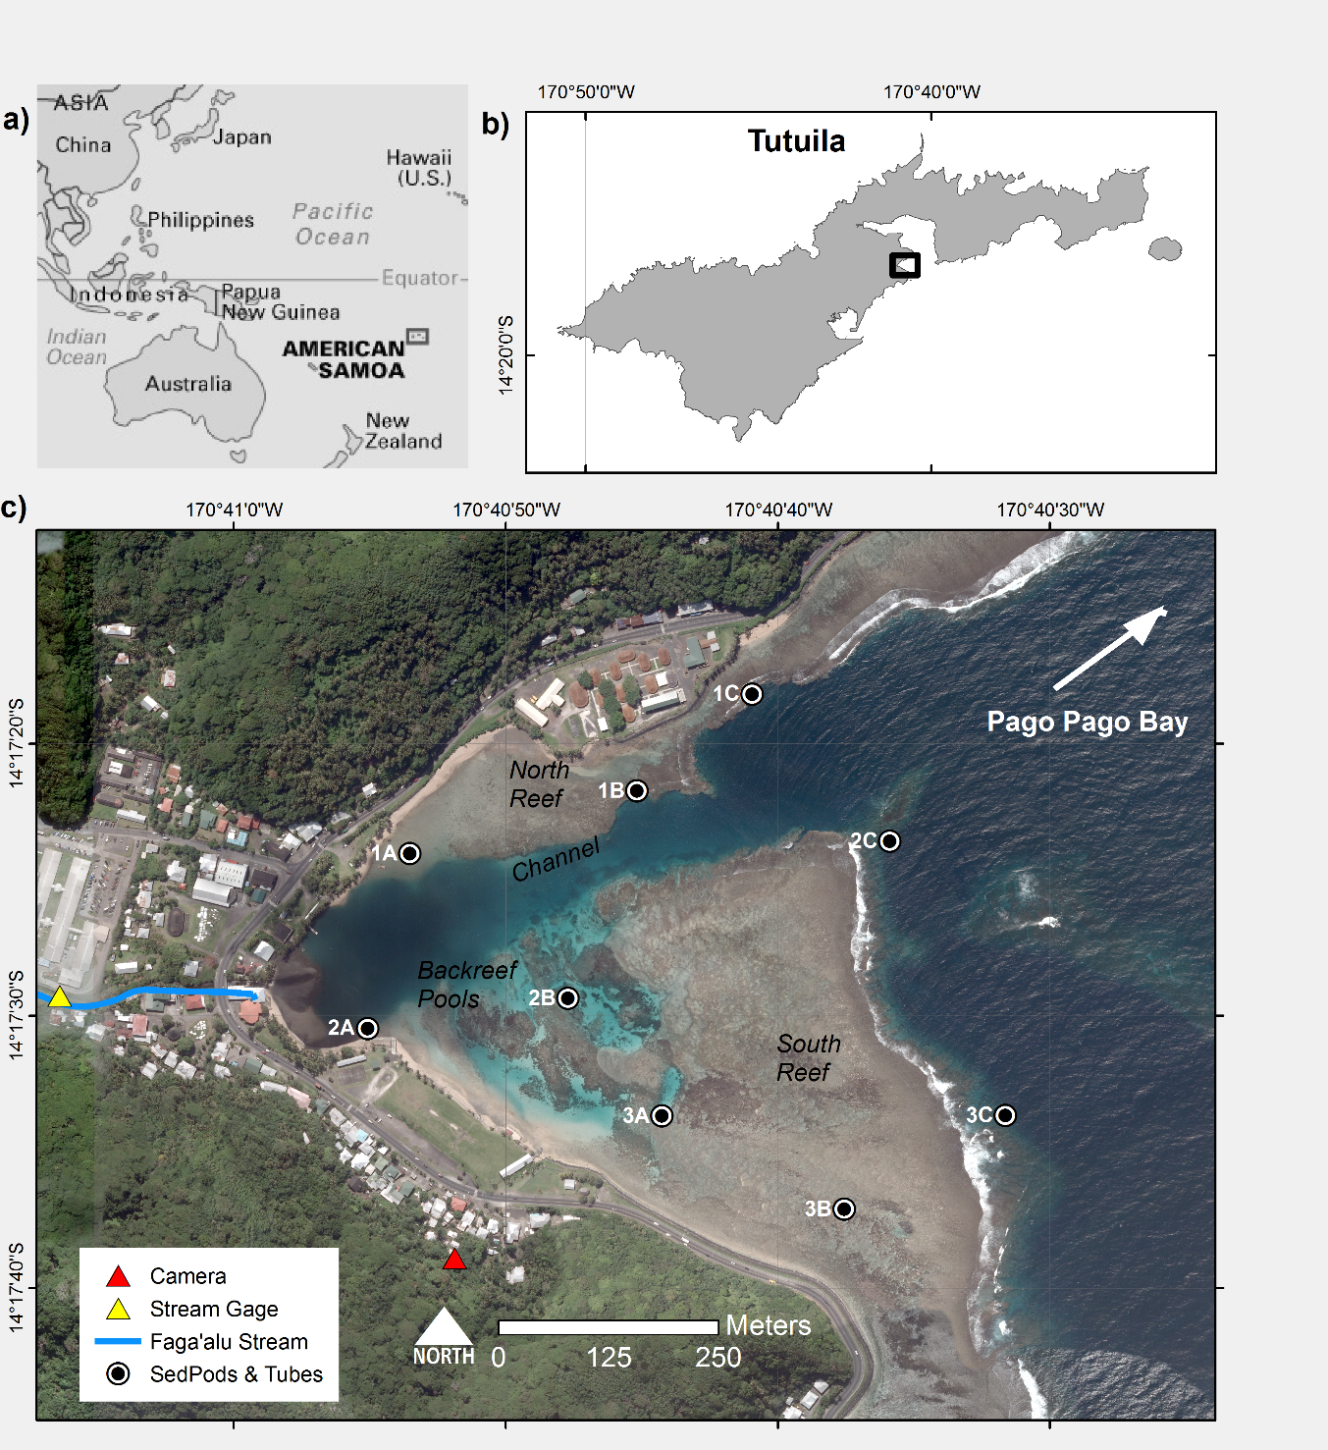

Figure 1. Maps of the study area and instrumentation in Faga'alu Bay. a) Location of American Samoa in the South Pacific region. b) Location of Faga’alu Bay on Tutuila Island, American Samoa. c) Sediment pods and sediment traps were deployed at nine locations for one year and collected quasi-monthly to measure sediment accumulation rates and composition. Suspended sediment yield from the watershed was measured at “Stream Gage.” Further details on SSY measurements and modeling can be found in (Messina and Biggs, *in press*). A time-lapse camera was installed at “Camera” to record images of transient sediment plumes during storms.

## Figure 2 Pictures of sediment traps



Figure 2. Pictures of the sediment traps and sediment pods at high tide. a-b) At Site 3A in an area of branching coral rubble, approximately 2 m depth. c) Capping the sediment pod for retrieval at Site 1C, approximately 10 m depth. d) At Site 1B, the surrounding area is mixed terrigenous and carbonate benthic sediment.

## Figure 3 SSY and Waves

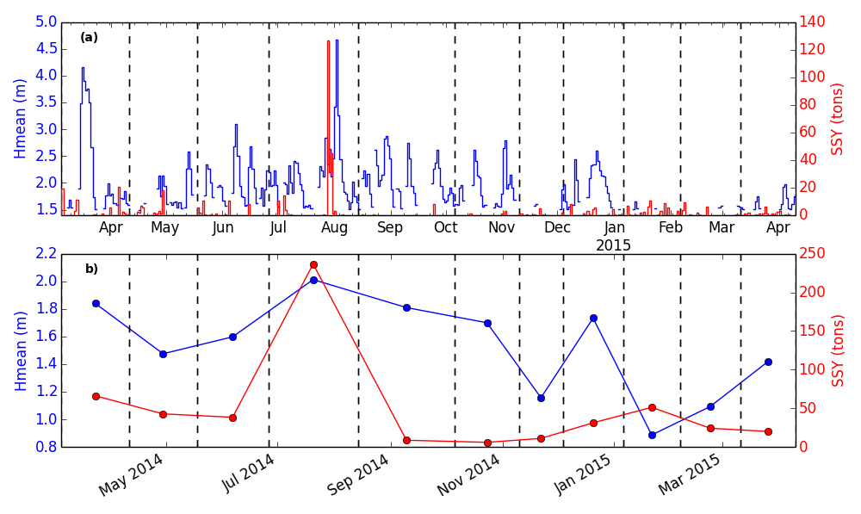

Figure 3. Suspended sediment yield from Faga’alu Stream (SSY) and wave conditions at the study site during sediment trap deployments. a) Mean daily significant wave height (m) exceeding 1.5 m from the NOAA WaveWatch III Samoa Regional Model and total daily Suspended Sediment Yield (SSY) (tons). b) Mean significant wave height (m) and total SSY during deployment periods (dashed lines indicate sample collection dates).

## Figure 4 Time lapse of sediment plume

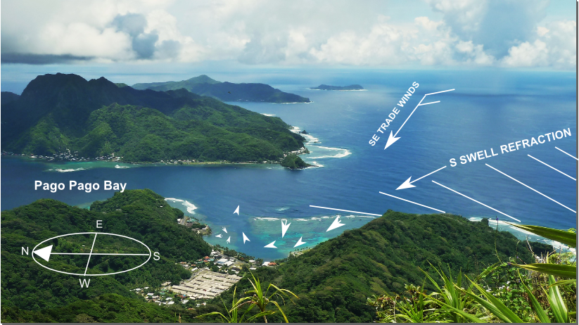

Camera

View

a)

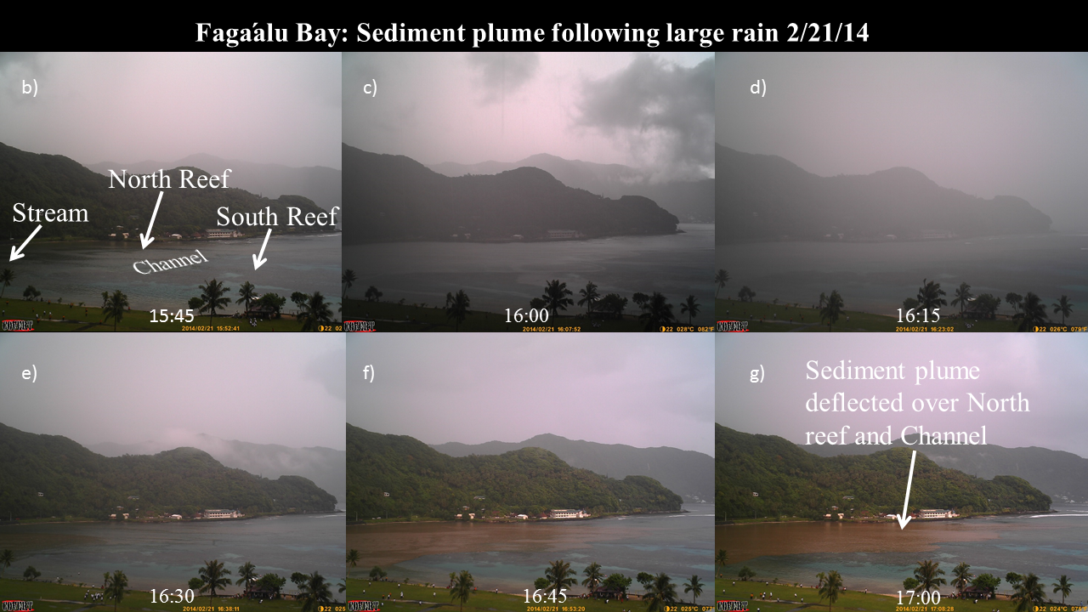

b)

Figure 4. Time lapse photography of a sediment plume discharged from Faga’alu Stream following a rain event 2/21/14. a) Illustration of dominant wind and wave-forcing, and resulting water flow patterns b) Time series of sediment plume following a brief but intense rainfall. In frame 1 the Bay is clear of any sediment plume but following a short burst of rainfall in frame 2 and 3, a sediment plume is discharged from the stream outlet (frames 4-6) where it is deflected away from the South reef, over the North reef and channel, and out to sea. Later frames showed the same spatial pattern, and an apparent diminishing of sediment concentrations over the northern reef.

## Figure 5 Mean accumulation and benthic composition

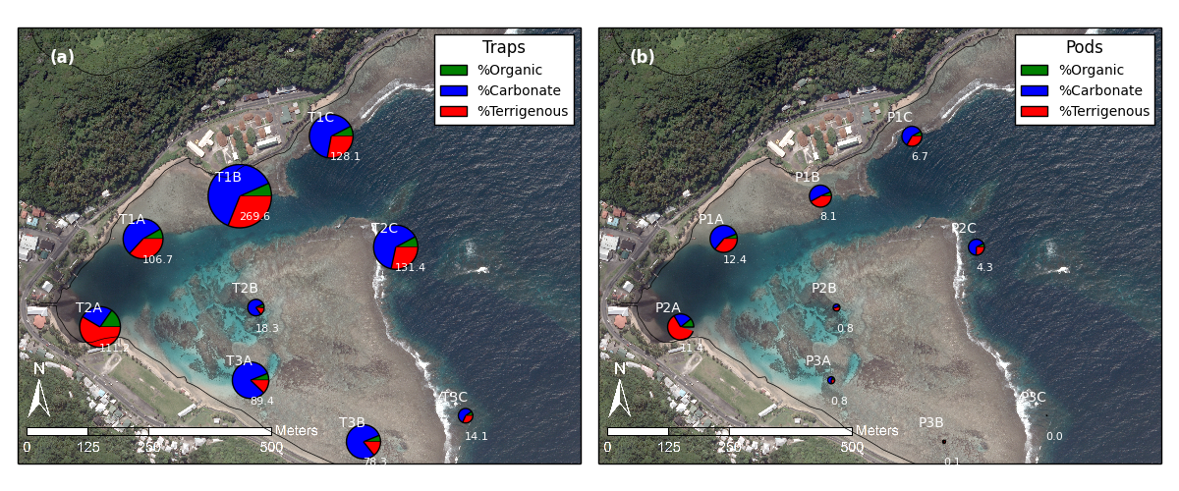

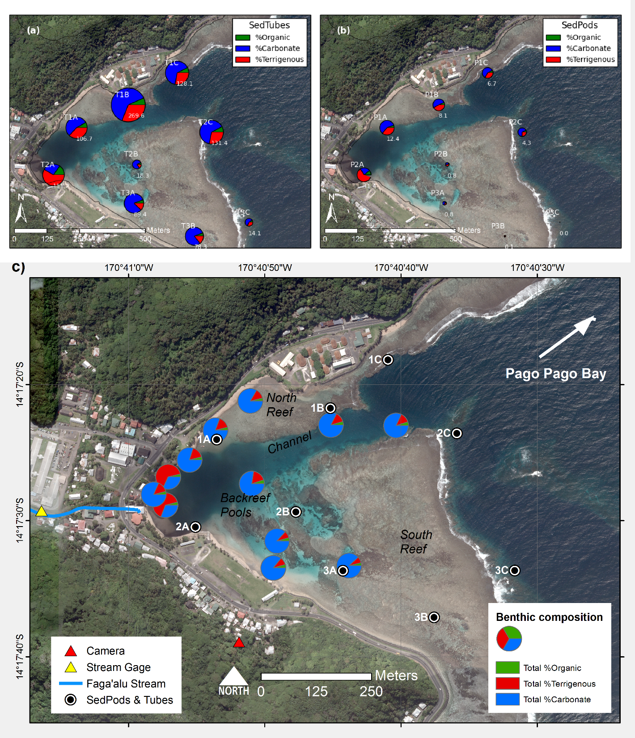

Figure 5. Mean sediment accumulation rates (g m-2 d-1) and composition at sediment traps and sediment pods in Faga’alu Bay during all deployments. a) Sediment traps. b) Sediment pods. c) Benthic sediment composition. Note: Subplot scales are different for visualization purposes, can’t compare sizes of charts, hence numbers included.

## Figure 6 Mean accumulation time series-sediment pods

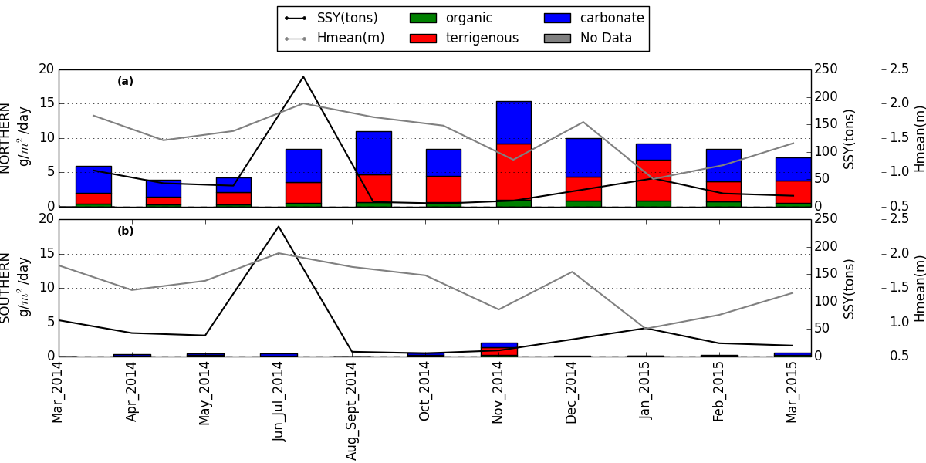

Figure 6. Mean sediment accumulation (g m-2 d-1) on sediment pods during the study period over the a) north reef including sites 1A, 1B, 1C, 2A, 2C, and b) south reefs including sites 2B, 3A, 3B, 3C.

## Figure 7 Mean accumulation time series-sediment traps

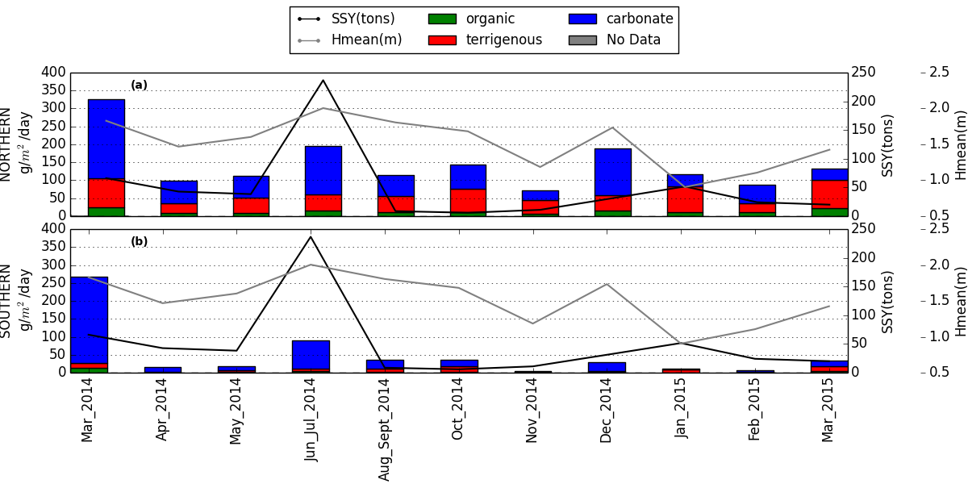

Figure 7. Mean sediment accumulation (g m-2 d-1) in sediment traps during the study period over the a) north reef including sites 1A, 1B, 1C, 2A, 2C, and b) south reefs including sites 2B, 3A, 3B, 3C

## Figure 8 Sediment accumulation time series- sediment pods

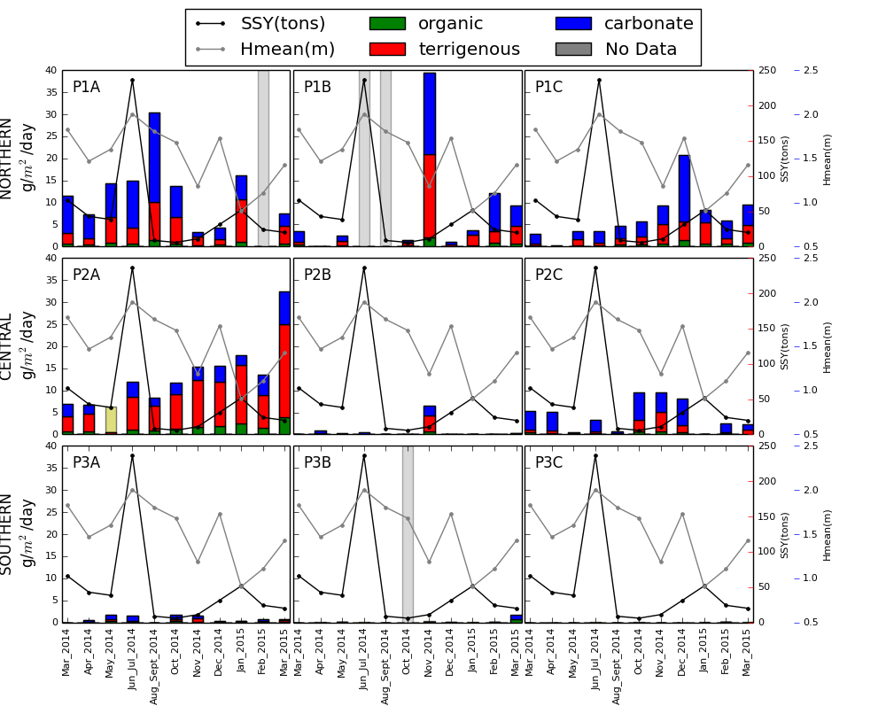

Figure 8. Time series' of sediment accumulation (g m-2 d-1) and composition on sediment pods at nine sediment trap locations in Faga'alu Bay, related to suspended-sediment yield from the watershed (SSY) and mean significant wave height (m). “P” indicates sediment “pod” and location ID’s (ex. 2A) correspond to sites in Figure 1.

## Figure 9 Sediment accumulation time series- sediment traps

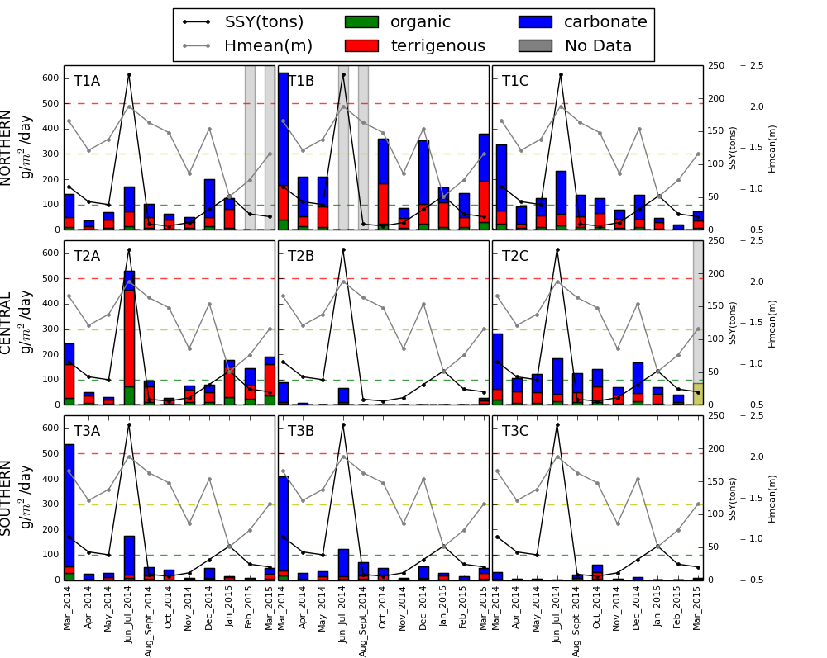

Figure 9. Time series' of sediment accumulation in sediment traps and composition at nine sediment trap locations in Faga'alu Bay, related to suspended sediment yield from the watershed (SSY) and mean significant wave height (m). “T” indicates sediment “trap” and location ID’s (ex. 2A) correspond to sites in Figure 1. Coral health thresholds related to sediment accumulation in tubes from *Erftemeijer et al. (2012)* are shown as dotted horizontal lines: <100 g m-2 d-1 = no stress, 100 – 300 g m-2 d-1 = stress recruits, 300 – 500 g m-2 d-1 = stress colonies, >500 g m-2 d-1 = lethal.

## Figure 10 Correlations

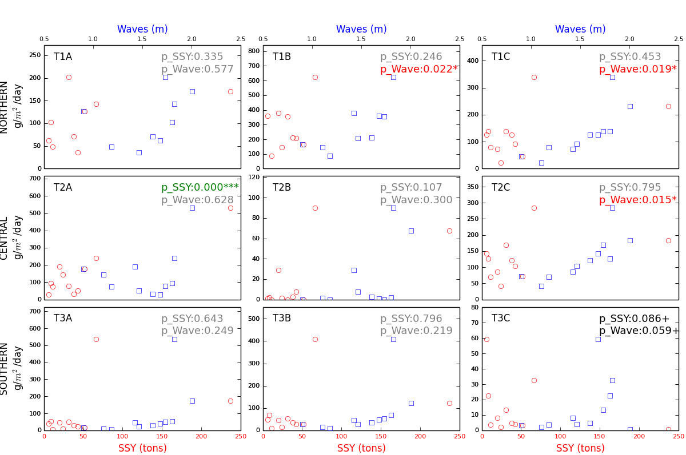

Figure 10. Correlations between total sediment accumulations in sediment traps vs SSY, mean wave height*. P-*values are for multiple regression

# References

Basher, L., Hicks, D., Clapp, B., & Hewitt, T. (2011). Sediment yield response to large storm events and forest harvesting, Motueka River, New Zealand. *New Zealand Journal of Marine and Freshwater Research*, *45*(3), 333–356. https://doi.org/10.1080/00288330.2011.570350

Bégin, C., Brooks, G., Larson, R. a., Dragićević, S., Ramos Scharrón, C. E., & Coté, I. M. (2014). Increased sediment loads over coral reefs in Saint Lucia in relation to land use change in contributing watersheds. *Ocean and Coastal Management*, *95*, 35–45. https://doi.org/10.1016/j.ocecoaman.2014.03.018

Bellwood, D. R., & Fulton, C. J. (2008). Sediment-mediated suppression of herbivory on coral reefs: Decreasing resilience to rising sea-levels and climate change? *Limnology and Oceanography*, *53*(6), 2695–2701. https://doi.org/10.4319/lo.2008.53.6.2695

Bever, A. J., McNinch, J. E., & Harris, C. K. (2011). Hydrodynamics and sediment-transport in the nearshore of Poverty Bay, New Zealand: Observations of nearshore sediment segregation and oceanic storms. *Continental Shelf Research*, *31*(6), 507–526. https://doi.org/10.1016/j.csr.2010.12.007

Bothner, M. H., Reynolds, R. L., Casso, M. A., Storlazzi, C. D., & Field, M. E. (2006). Quantity, composition, and source of sediment collected in sediment traps along the fringing coral reef off Molokai, Hawaii. *Marine Pollution Bulletin*, *52*(9), 1034–1047. https://doi.org/10.1016/j.marpolbul.2006.01.008

Brooks, G., Devine, B., Larson, R., & Rood, B. (2007). Sedimentary Development of Coral Bay , St . John , USVI : A Shift From Natural to Anthropogenic Influences. *Caribbean Journal of Science*, *43*(2), 226–243.

Browne, N. K. ., Smithers, S. G. ., Perry, C. T. ., & Ridd, P. V. . (2012). A Field-Based technique for measuring sediment flux on coral reefs: Application to turbid reefs on the great barrier reef. *Journal of Coastal Research*, *28*(5), 1247–1262. https://doi.org/10.2112/JCOASTRES-D-11-00171.1

Cochran, S. A., Gibbs, A. E., D’Antonio, N. L., & Storlazzi, C. D. (2016). *Benthic habitat map of U.S. Coral Reef Task Force Faga‘alu Bay priority study area, Tutuila, American Samoa: U.S. Geological Survey Open-File Rport 2016-1077*. https://doi.org/http://dx.doi.org/10.3133/

Craig, P. (2009). *Natural History Guide to American Samoa*. National Park of American Samoa.

Dames & Moore. (1981). *Hydrologic Investigation of Surface Water for Water Supply and Hydropower* (p. 63). U.S. Army Engineer District, Honolulu.

DeMartini, E., Jokiel, P., Beets, J., Stender, Y., Storlazzi, C., Minton, D., & Conklin, E. (2013). Terrigenous sediment impact on coral recruitment and growth affects the use of coral habitat by recruit parrotfishes (F. Scaridae). *Journal of Coastal Conservation*, *17*(3), 417–429. https://doi.org/10.1007/s11852-013-0247-2

Draut, A. E., Bothner, M. H., Field, M. E., Reynolds, R. L., Cochran, S.A.Logan, J. B., Storlazzi, C. D., & Berg, C. J. (2009). Supply and dispersal of flood sediment from a steep, tropical watershed: Hanalei Bay, Kaua’i, Hawai’i, USA. *Geological Society of America Bulletin*, *121*(3–4), 574–585. https://doi.org/10.1130/B26367.1

Duckworth, A., Giofre, N., & Jones, R. (2017). Coral morphology and sedimentation. *Marine Pollution Bulletin*, *125*(1–2), 289–300. https://doi.org/10.1016/j.marpolbul.2017.08.036

Duvert, C., Nord, G., Gratiot, N., Navratil, O., Nadal-Romero, E., Mathys, N., Némery, J., Regüés, D., García-Ruiz, J. M., Gallart, F., & Esteves, M. (2012). Towards prediction of suspended sediment yield from peak discharge in small erodible mountainous catchments (0.45–22km2) of France, Mexico and Spain. *Journal of Hydrology*, *454*–*455*, 42–55. https://doi.org/10.1016/j.jhydrol.2012.05.048

Erftemeijer, P. L. a, Riegl, B., Hoeksema, B. W., & Todd, P. a. (2012). Environmental impacts of dredging and other sediment disturbances on corals: A review. *Marine Pollution Bulletin*, *64*(9), 1737–1765. https://doi.org/10.1016/j.marpolbul.2012.05.008

Fabricius, K. E. (2005). Effects of terrestrial runoff on the ecology of corals and coral reefs: review and synthesis. *Marine Pollution Bulletin*, *50*(2), 125–146. https://doi.org/10.1016/j.marpolbul.2004.11.028

Fabricius, K. E., De’ath, G., Humphrey, C., Zagorskis, I., & Schaffelke, B. (2012). Intra-annual variation in turbidity in response to terrestrial runoff on near-shore coral reefs of the Great Barrier Reef. *Estuarine, Coastal and Shelf Science*, *116*, 57–65. http://www.sciencedirect.com/science/article/pii/S0272771412000832

Feagaimaalii-Luamanu, J. (2016, January 19). High surf generated by TC Victor washes over roads and property. *Samoa News*. http://www.samoanews.com/content/en/high-surf-generated-tc-victor-washes-over-roads-and-property

Field, M. E., Chezar, H., & Storlazzi, C. D. (2012). SedPods: a low-cost coral proxy for measuring net sedimentation. *Coral Reefs*, *32*(1), 155–159. https://doi.org/10.1007/s00338-012-0953-5

Gray, S. C., Sears, W., Kolupski, M. L., Hastings, Z. C., Przyuski, N. W., Fox, M. D., & Degrood, A. (2012). Factors affecting land-based sedimentation in coastal bays, US Virgin Islands. *12th International Coral Reef Symposium*, *July*, 9–13.

Heiri, O., Lotter, A. F., & Lemcke, G. (2001). Loss on ignition as a method for estimating organic and carbonate content in sediments : reproducibility and comparability of results. *Journal of Paleolimnology*, *25*, 101–110.

Hettler, J., Irion, G., & Lehmann, B. (1997). Environmental impact of mining waste disposal on a tropical lowland river system: a case study on the Ok Tedi Mine, Papua New Guinea. *Mineralium Deposita*, *32*(3), 280–291. https://doi.org/10.1007/s001260050093

Hoitink, A. J. F., & Hoekstra, P. (2003). Hydrodynamic control of the supply of reworked terrigenous sediment to coral reefs in the Bay of Banten (NW Java, Indonesia). *Estuarine, Coastal and Shelf Science*, *58*(4), 743–755.

Holst-Rice, S., Messina, A., Biggs, T. W., Vargas-Angel, B., & Whitall, D. (2016). *Baseline Assessment of Fagaʻalu Watershed: A Ridge to Reef Assessment in Support of Sediment Reduction Activities and Future Evaluation of their Success*. NOAA Coral Reef Conservation Program. https://doi.org/10.7289/V5BK19C3

Jokiel, P. L., Rodgers, K. S., Storlazzi, C. D., Field, M. E., Lager, C. V., & Lager, D. (2014). Response of reef corals on a fringing reef flat to elevated suspended-sediment concentrations: Molokaʻi, Hawaiʻi. *PeerJ*, *2*(e699). https://doi.org/10.7717/peerj.699

Jones, R., Bessell-Browne, P., Fisher, R., Klonowski, W., & Slivkoff, M. (2015). Assessing the impacts of sediments from dredging on corals. *Marine Pollution Bulletin*, *102*(1), 9–29. https://doi.org/10.1016/j.marpolbul.2015.10.049

Klein, C. J., Jupiter, S. D., Selig, E. R., Watts, M. E., Halpern, B. S., Kamal, M., Roelfsema, C., & Possingham, H. P. (2012). Forest conservation delivers highly variable coral reef conservation outcomes. *Ecological Applications*, *22*(4), 1246–1256. http://www.ncbi.nlm.nih.gov/pubmed/22827132

Meng, P.-J., Lee, H.-J., Wang, J.-T., Chen, C.-C., Lin, H.-J., Tew, K. S., & Hsieh, W.-J. (2008). A long-term survey on anthropogenic impacts to the water quality of coral reefs, southern Taiwan. *Environmental Pollution*, *156*(1), 67–75. https://doi.org/10.1016/j.envpol.2007.12.039

Messina, A. T., & Biggs, T. W. (2016). Contributions of human activities to suspended sediment yield during storm events from a small, steep, tropical watershed. *Journal of Hydrology*, *538*, 726–742.

Militello, A., Scheffner, N. W., & Thompson, E. F. (2003). *Hurrican-Induced Stage-Frequency Relationships for the Territory of American Samoa. USACOE Technical Report CHL-98-33*.

Muzuka, A. N. N., Dubi, A. M., Muhando, C. A., & Shaghude, Y. W. (2010). Impact of hydrographic parameters and seasonal variation in sediment fluxes on coral status at Chumbe and Bawe reefs, Zanzibar, Tanzania. *Estuarine, Coastal and Shelf Science*, *89*(2), 137–144.

Nakamura, S. (1984). *Soil Survey of American Samoa*. US Department of Agriculture Soil Conservation Service. http://books.google.com/books?id=NSCSQgAACAAJ

PACIOOS, P. I. O. O. S. (2016). *WaveWatch III Samoa Regional Model*. http://oos.soest.hawaii.edu/pacioos/

Perreault, J. (2010). *Development of a Water Budget in a Tropical Setting Accounting for Mountain Front Recharge: Tutuila, American Samoa* (Issue August). University of Hawai’i.

Pomeroy, A. W. M., Lowe, R. J., Ghisalberti, M., Storlazzi, C. D., Cuttler, M., & Symonds, G. (2015). Mechanics of Sediment Suspension and Transport Within a Fringing Reef. *Coastal Sediments 2015*, 1–14.

Ramos-Scharrón, C. E., & Macdonald, L. H. (2007). Measurement and prediction of natural and anthropogenic sediment sources, St. John, US Virgin Islands. *Catena*, *71*(2), 250–266.

Rangel-Buitrago, N., Anfuso, G., Phillips, M., Thomas, T., Alvarez, O., & Forero, M. (2014). Characterization of wave climate and extreme events into the SW Spanish and Wales coasts as a first step to define their wave energy potential. *Journal of Coastal Research*, *70*(March 2016), 314–319. https://doi.org/10.2112/SI70-053.1

Ryan, K. E., Walsh, J. P., Corbett, D. R., & Winter, a. (2008). A record of recent change in terrestrial sedimentation in a coral-reef environment, La Parguera, Puerto Rico: a response to coastal development? *Marine Pollution Bulletin*, *56*(6), 1177–1183. https://doi.org/10.1016/j.marpolbul.2008.02.017

Santisteban, J. I., Mediavilla, R., Lopez-Pamo, E., Dabrio, C. J., Zapata, M. B. R., Garcia, M. J. G., Castano, S., & Martínez-Alfaro, P. E. (2004). Loss on ignition: a qualitative or quantitative method for organic matter and carbonate mineral content in sediments? *Journal of Paleolimnology*, *32*(3), 287–299.

Seymour, R. J. (2011). Evidence for Changes to the Northeast Pacific Wave Climate. *Journal of Coastal Research*, *27*(1), 194–201. https://doi.org/10.2112/JCOASTRES-D-09-00149.1

Storlazzi, C. D., Cheriton, O. M., Messina, A. M., & Biggs, T. W. (2018). Meteorologic, oceanographic, and geomorphic controls on circulation and residence time in a coral reef-lined embayment: Faga’alu Bay, American Samoa. *Coral Reefs*. https://doi.org/10.1007/s00338-018-1671-4

Storlazzi, Curt D., Field, M. E., & Bothner, M. H. (2011). The use (and misuse) of sediment traps in coral reef environments: theory, observations, and suggested protocols. *Coral Reefs*, *30*(1), 23–38.

Storlazzi, Curt D., Field, M. E., Bothner, M. H., Presto, M. K., & Draut, A. E. (2009). Sedimentation processes in a coral reef embayment: Hanalei Bay, Kauai. *Marine Geology*, *264*(3–4), 140–151. https://doi.org/10.1016/j.margeo.2009.05.002

Storlazzi, Curt D., & Jaffe, B. E. (2008). The relative contribution of processes driving variability in flow, shear, and turbidity over a fringing coral reef: West Maui, Hawaii. *Estuarine, Coastal and Shelf Science*, *77*(4), 549–564.

Storlazzi, Curt D., Norris, B. K., & Rosenberger, K. J. (2015). The influence of grain size, grain color, and suspended-sediment concentration on light attenuation: Why fine-grained terrestrial sediment is bad for coral reef ecosystems. *Coral Reefs*, *34*(3), 967–975. https://doi.org/10.1007/s00338-015-1268-0

Tebbett, S. B., Goatley, C. H. R., & Bellwood, D. R. (2017). Fine sediments suppress detritivory on coral reefs. *Marine Pollution Bulletin*. https://doi.org/10.1016/j.marpolbul.2016.11.016

Teneva, L. T., Mcmanus, M. A., Jerolmon, C., Neuheimer, A. B., Clark, S. J., Walker, G., Kaho, K., Shimabukuro, E., Ostrander, C., & Kittinger, J. N. (2016). Understanding Reef Flat Sediment Regimes and Hydrodynamics can Inform Erosion Mitigation on Land. *Collabra*, *2*(1), 1–12.

Thomas, S., & Ridd, P. (2005). Field assessment of innovative sensor for monitoring of sediment accumulation at inshore coral reefs. *Marine Pollution Bulletin*, *51*(1–4), 470–480. https://doi.org/10.1016/j.marpolbul.2004.10.026

Thompson, E. F., & Demirbilek, Z. (2002). *Wave Response, Pago Pago Harbor, Island of Tutuila, Territory of American Samoa. USACOE Coastal and Hydraulics Laboratory ERDC/CHL TR-02-20* (Issue September).

Tonkin & Taylor International Ltd. (1989). *Hydropower feasibility studies interim report - Phase 1. Ref: 97/10163*.

Vetter, O. (2013). *Inter-Disciplinary Study of Flow Dynamics and Sedimentation Effects on Coral Colonies in Faga’alu Bay, American Samoa: Oceanographic Investigation Summary. NOAA CRCP Project #417*. http://data.nodc.noaa.gov/coris/library/NOAA/CRCP/project/417/Fagaalu_Oceanographic_Document.pdf

Victor, S., Neth, L., Golbuu, Y., Wolanski, E., & Richmond, R. H. (2006). Sedimentation in mangroves and coral reefs in a wet tropical island, Pohnpei, Micronesia. *Estuarine, Coastal and Shelf Science*, *66*(3–4), 409–416. https://doi.org/10.1016/j.ecss.2005.07.025

Warrick, J. A., Mertes, L. A. K., Washburn, L., & Siegel, D. A. (2004). Dispersal forcing of southern California river plumes, based on field and remote sensing observations. *Geo-Marine Letters*, *24*(1), 46–52.

Weber, M., de Beer, D., Lott, C., Polerecky, L., Kohls, K., Abed, R. M. M., Ferdelman, T. G., & Fabricius, K. E. (2012). Mechanisms of damage to corals exposed to sedimentation. *Proceedings of the National Academy of Sciences*, *109*(24), E1558–E1567.

Whinney, J., Jones, R., Duckworth, A., & Ridd, P. (2017). Continuous in situ monitoring of sediment deposition in shallow benthic environments. *Coral Reefs*. https://doi.org/10.1007/s00338-016-1536-7

Wolanski, E., Fabricius, K. E., Spagnol, S., & Brinkman, R. (2005). Fine sediment budget on an inner-shelf coral-fringed island, Great Barrier Reef of Australia. *Estuarine, Coastal and Shelf Science*, *65*(1), 153–158.

Wolanski, E., Richmond, R. H., Davis, G., & Bonito, V. (2003). Water and fine sediment dynamics in transient river plumes in a small, reef-fringed bay, Guam. *Estuarine, Coastal and Shelf Science*, *56*(5–6), 1029–1040. https://doi.org/10.1016/S0272-7714(02)00321-9

Wong, M. (1996). *Analysis of Streamflow Characteristics for Streams on the Island of Tutuila, American Samoa. U.S. Geological Survey Water-Resources Investigations Report 95-4185*. U.S. Geological Survey.